TouchKey Module Description Document

**1. Introduction**  
The AP80 series chips utilize the principle of RC oscillation for TouchKey functionality. An oscillation loop is formed between two GPIO pins, and a fixed-frequency ADC inside the chip samples this RC oscillation loop. By detecting changes in the oscillation period, it determines whether a key press has occurred.

When touched, the oscillation period of the RC circuit becomes longer, the frequency decreases, and the number of cycles detected by the AP80’s internal counter increases, resulting in a higher Dout value.

The AP80 series chips can provide up to 14 TouchKey analog channels: GPIOB[26] to GPIOB[31] and GPIOC[1] to GPIOC[8]. GPIOC[0] is used as the digital output channel. At any given time, only one analog channel can form the oscillation loop with GPIOC[0]; different analog channels can be used at different times, supporting up to 14 analog channels in total.

Note: The resistor used in the RC oscillation loop is typically 61.9KΩ. The sensor area (capacitive area) should generally be no larger than an active finger. For optimal balance, this size is typically designed between that of a child’s small finger and an adult’s large finger, but the final size should depend on the actual application. Keep in mind that any sensor area beyond the finger coverage is essentially redundant, as it will not contribute to a significant change in capacitance.

**2. Typical Application**

**2.1. Obtaining Dout values from multiple channels**

First, reset the module with TouchKeyModuleRst(). Then, use TouchKeyPortInit(TouchKeyPin) to initialize the relevant pins into the corresponding analog and digital paths.

Next, call TouchKeyStartConvert(ChSel) to start sampling the current channel, and continuously poll TouchKeyIsConvertOK() to check whether the sampling is complete.

Once complete, call TouchKeyGetDout() to obtain the Dout value of the current channel. Then, call TouchKeyStartConvert(ChSeln) to start sampling the next channel, and repeat the above steps to get Dout values for multiple channels.

Note: tkpin: the corresponding GPIO multiplexing path.chSel: the channel number corresponding to the GPIO path during measurement.

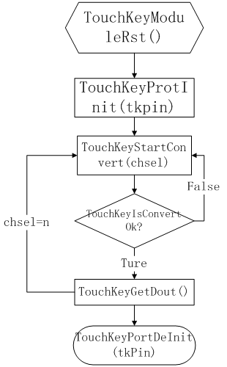

Figure 1 — TouchKey operation diagram